**Table of Contents**

Problem 1: Sorting 4 numbers 3

Problem 2: Leap Year 3

Problem 3: Digits Manipulation 3

Problem 4: Right Angle Triangle 3

Problem 5: Count input digits 3

Problem 6: In order or not in order 4

Problem 7: Armstrong number 4

Problem 8: Answer the questions. 4

Problem 9: Write Output. 4

|  |  |
| --- | --- |
| Problem 1: Sorting 4 numbers |  |

Write a C++ program that takes 3 numbers as an input from user. You are required to sort them by printing them in ascending order.

**Sample output:**

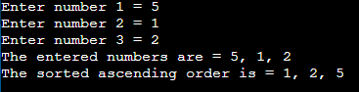

|  |  |
| --- | --- |
| Problem 2: Leap years |  |

Leap years have 366 days (29 days in February). Any year that is divisible by 4 but not by 100 is a leap year. If a year is divisible by 400 then it is also a leap year. So, in short, any year that is divisible by 4 is a leap year, unless it is divisible by 100, in which case it must also be divisible by 400 for it to be a leap year.

Example: 1996 and 2000 were leap years, but 1900 was not.

Write a C++ program to determine if a year input by a user is a leap year or not.

|  |  |
| --- | --- |
| Problem 3: Digits Manipulation |  |

Write a C++ program that takes a 4-digit number from user and prints the digits of the number in English.

If input is 8923 then output should be Eight Nine Two Three.

|  |  |
| --- | --- |
| Problem 4: Right Angle Triangle |  |

Write a C++ program that prompts the user to enter the lengths of three sides of a triangle and then outputs a message indicating whether the triangle is a right triangle.

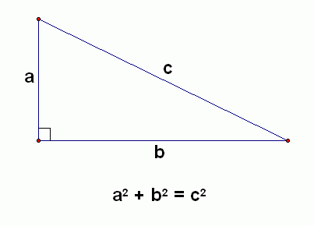

|  |  |
| --- | --- |
| Problem 5: Count input digits |  |

Design a C++ program that takes a 6-digit number as input and it prints the count of all digits (0 to 9) only if the digits count is greater than zero.

|  |  |
| --- | --- |
| Problem 6: In order or not in order |  |

Write a C++ program that reads in three integers and prints “in order” if they are sorted in descending then **“in order**, or “**not in order**” otherwise.

The sample output is given below:

# 1 2 5 not in order

# 1 5 2 not in order

# 5 2 1 in order

1 2 2 not in order

|  |  |
| --- | --- |
| Problem 7: Armstrong number |  |

A number is Armstrong number if the sum of the cubes of its digits is equal to the number itself. For example, 371 is an Armstrong number since 3*3*3 + 7*7*7 + 1*1*1 = 371.

You should write a program which asks user to enter a number and your program should check whether the number is Armstrong or not.

|  |  |
| --- | --- |
| Problem 8: Answer the questions. |  |

1. **Answer the questions below concerning the following fragment of code.**

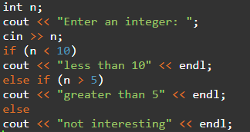

a)       What will be the output of the fragment above if the interactive user enters the integer value 0?

b)      What will be the output of the fragment above if the interactive user enters the integer value 15?

c)       What will be the output of the fragment above if the interactive user enters the integer value 7?

d)      What values for n will cause the output of the fragment above to be "not interesting"?

**2)  Remove all the unnecessary tests from the nested conditional statement below.**

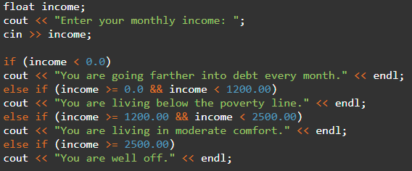

|  |  |
| --- | --- |
| Problem 9: |  |

Determine the output of each variable at each line.

Int main ()

{

int x = 0;

int y = 5;

int z = 1;

x++;

y -= 3;

z = x + z;

x = y * z;

y %= 2;

z--;

}